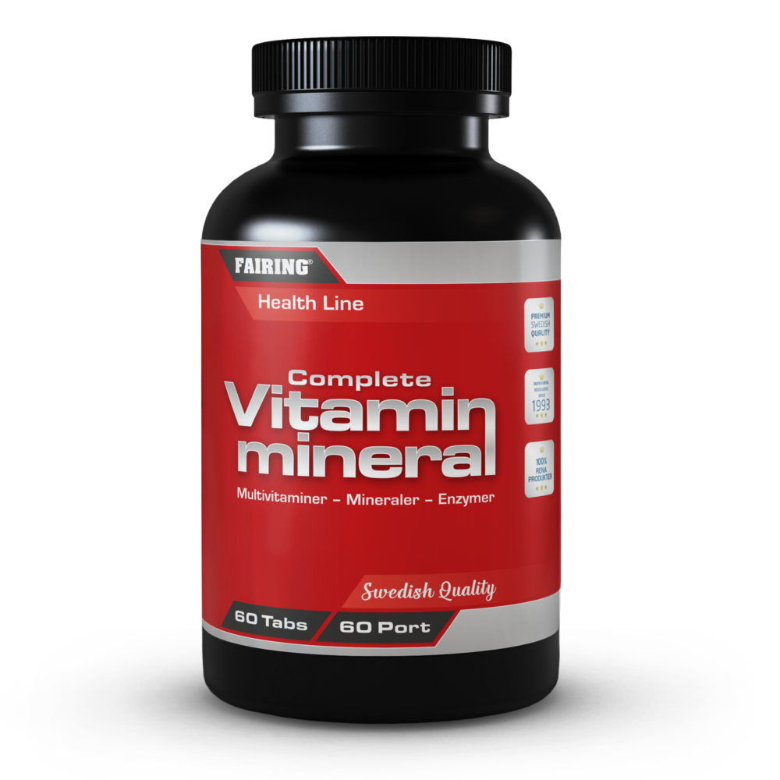
Complete Vitamin & Mineral, 60 tabs

FAIRING Complete Vitamin & Mineral – The easiest way to ensure your body is getting the essential vitamins, minerals, and nutrients you need to stay healthy.
Support immune health with vitamins C & D - Vitamin C is associated with immune system health, which may be due to its ability to scavenge free radicals and protect against oxidative stress, as well as its stimulation of the production and function of white blood cells. Vitamin D supports immune system health, bone health and more. Suitable for vegans & vegetarians.

SERVINGS PER CONTAINER
60
SERVING SIZE
1 tablet a day
DIRECTIONS
1 tablet daily, preferably with a meal. Do not exceed 2 tablets/day.

SUPPLEMENT FACTS
Amount | Per servering | RDI*
Vitamin A (Beta Carotene) | 833 ug | 104%
Vitamin B1 (Thiamin) | 6,25 mg | 568%
Vitamin B2 (Riboflavin) | 6,25 mg | 446%
Vitamin _{B3} (Niacin) | 25 mg | 156%
Vitamin _{B5} (Pantotenic acid) | 6,25 mg | 104%
Vitamin _{B6} (Pyrodoxine) | 6,25 mg | 446%
Vitamin _{B8} (Biotin) | 75 ug | 150%
Vitamin _{B9} (Folic Acid) | 400 ug | 200%
Vitamin B12 (Cobalamine) | 12,5 ug | 500%
Vitamin C | 250 mg | 313%
Vitamin D | 5 ug | 100%
Vitamin E | 74 mg | 617%
Vitamin P (Bioflavonoid) | 25 mg
Betaine HCL | 20 mg
Choline | 12,5 mg
Paba | 12,5 mg
Iodine | 150 ug | 100%
Iron | 7,5 mg | 54%
Calcium | 125 mg | 16%
Potassium | 25 mg | 1,3%
Copper | 1 mg | 100%
Chromium | 25 ug | 63%
Magnesium | 125 mg | 33%
Manganese | 2,5 mg | 125%
Sodium | 0,025 mg | 50%
Selenium | 25 ug | 45%
Zink | 7,5 mg | 75%
OTHER INGREDIENTS
Bulking agents (microcrystalline celluloae, anti-caking agents (magnesium tearat, silica), lubricant (polysorbat), coating agent (hypromellos).

CAUTION
For adults only. Consult physician if pregnant/nursing, taking medication, or have a medical condition. Keep out of reach for children. Store tightly closed in a cool, dry place.
DIETARY SUPPLEMENT
Recommended daily dose should not be exceeded. Should not be used as an alternative to a varied and balanced diet and healthy lifestyle.

Manufactured in Sweden according to current EU standards.

